What's Included and Internet Testing

By Jayviar Laporte

Hello and Welcome! Below is the step-by-step documentation on what will be installed on our sever as well as a quick-check to see if we are on the internet.

Setting up pre installs:

1. When installing both servers. One may be prompted with a large list of files, programs, and installs to be downloaded with the server. In this demo, our Ubuntu server prompted us with this. CentOS 9 did not however this can depend on the version you are using.

*Note\* This demo may have ones selected that you may not want or need. This is just an example of what the screen looks like*

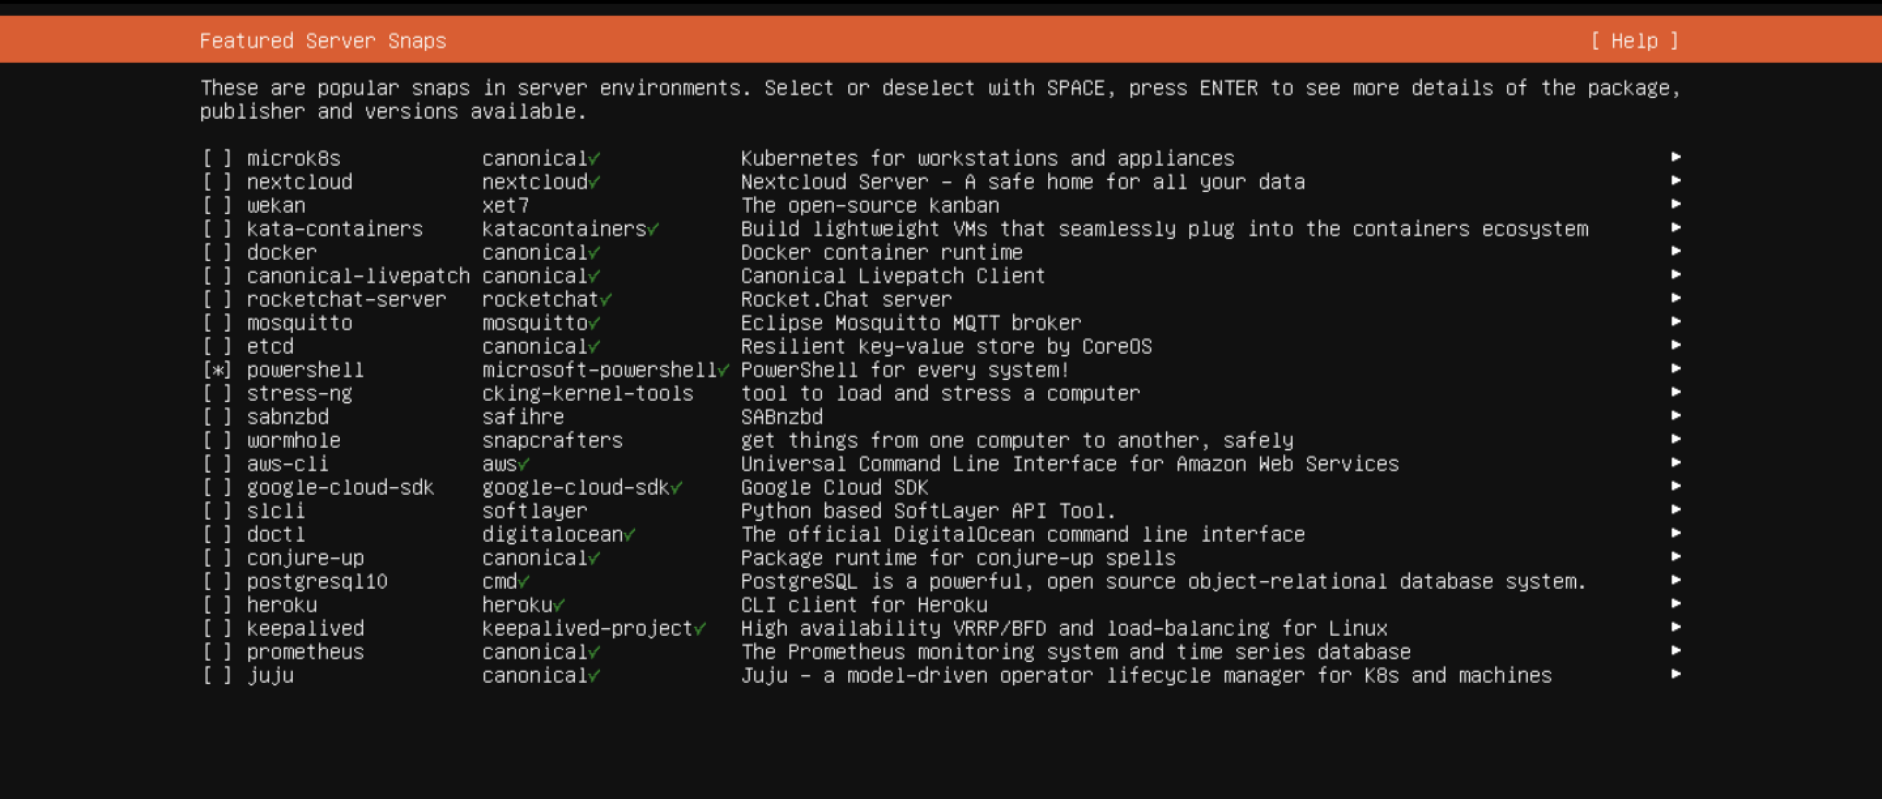

Testing Internet Connection:

To check If our servers have a valid internet connecton we will start by going into our Virtual Machine Settings for that Server and checking to see if the connection is being shared on our Host Computer to get a internet connection.

*Note\* You can configure the internet to whatever you need in order to get internet access. However, in this demo we will be connected to the host PC which happens to be a Mac but this is dependent on what your Host Pc is running*

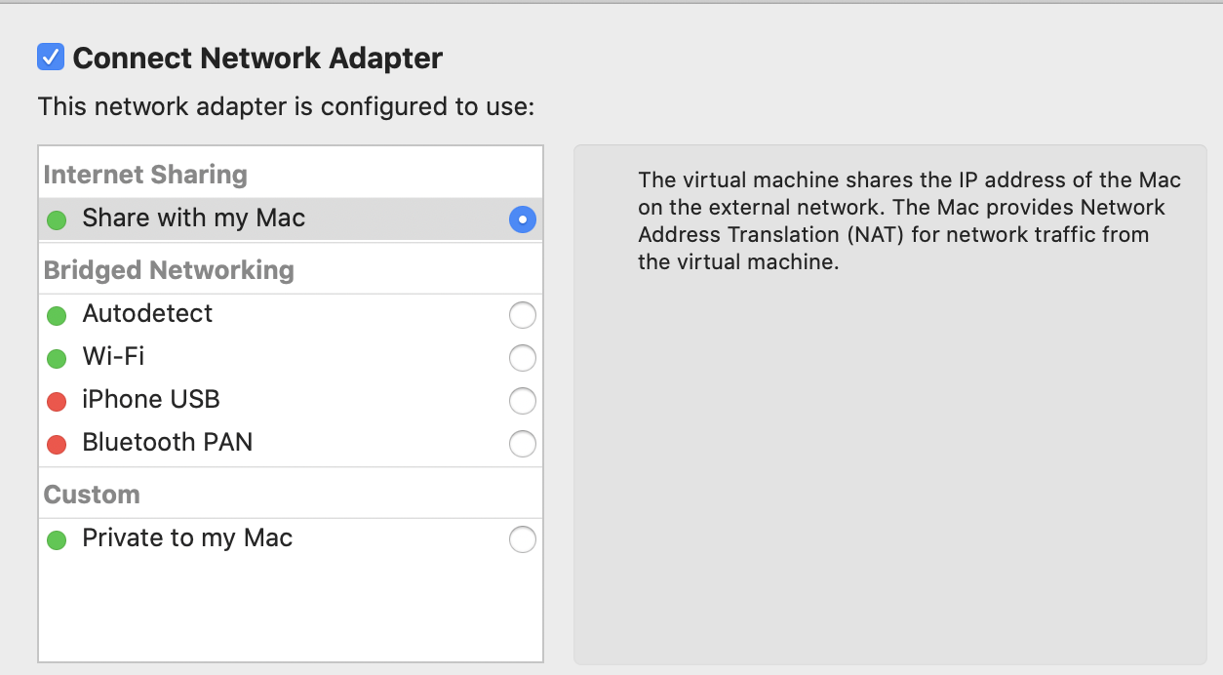

To Test the internet within our servers we can simply Run the ping command followed by the google.com address just to confirm we are connected to the internet.

